## **PROJECT REPORT**

### **SB Foods – OrderOnTheGo: Your On-Demand Food Ordering Solution**

### 1. INTRODUCTION

***1.1 Project Overview***

SB Foods is an intuitive web-based food ordering platform designed to transform the way users discover and order food online. The platform makes it easy to explore dishes, view details like reviews and pricing, and place orders seamlessly—anytime, anywhere.

***1.2 Purpose***

The purpose of SB Foods is to enhance convenience in food ordering, reduce wait times, and empower users with clear, comprehensive dish information so they can make confident choices and enjoy hassle-free ordering.

**2. IDEATION PHASE**

**2.1 Problem Statement**

Traditional food ordering methods can be time-consuming, unclear, and inconvenient—especially during late-night hours. There’s a need for an on-demand platform that offers detailed menus, reliable delivery, and real-time updates.

**2.2 Empathy Map Canvas**

**User (Foodie / Late-night customer):**

* Says: “I want food quickly, even at midnight.”
* Thinks: “Will the order actually arrive on time?”
* Feels: Hungry and anxious about delays.
* Does: Searches menus, reads reviews before ordering.

**Restaurant / Admin:**

* Says: “We want to reach more customers.”
* Thinks: “We need an easy way to manage orders.”
* Feels: Overwhelmed with manual phone orders.
* Does: Uses platform to update menus and track orders.

**2.3 Brainstorming**

• User-friendly order interface  
• Real-time order tracking  
• Detailed dish info with reviews and offers  
• Admin dashboard for restaurant owners  
• Secure user authentication

**3. REQUIREMENT ANALYSIS**

**3.1 Customer Journey Map**

| **Step** | **User Action** | **System Response** |
| --- | --- | --- |
| Explore | Browse menu & read reviews | Display dish details & ratings |
| Add to cart | Select dishes | Update cart & show total price |
| Checkout | Enter delivery details & payment | Save order & confirm with estimated delivery time |
| Track | Wait for food | Show order status updates until delivery |

**3.2 Solution Requirement**

• **Functional:** Login, browse dishes, add to cart, place order, view order history, admin panel  
• **Non-functional:** Responsive design, secure payments, scalability, real-time notifications

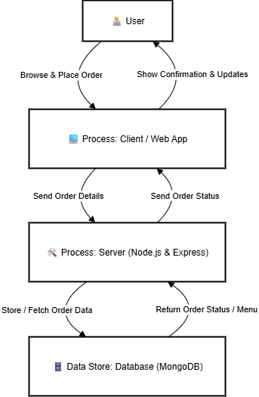**3.3 Data Flow Diagram**

**3.4 Technology Stack**

• Frontend: React.js + Tailwind CSS  
• Backend: Node.js + Express.js  
• Database: MongoDB  
• Authentication: JWT  
• Deployment: Netlify / Vercel / Railway

**4. PROJECT DESIGN**

**4.1 Problem Solution Fit**

Addresses late-night cravings and busy lifestyles by providing an always-available, seamless food ordering solution.

**4.2 Proposed Solution**

A web app enabling users to explore menus, see real reviews, order food, and track deliveries, supported by an admin dashboard for restaurant owners.

**4.3 Solution Architecture**



**5. PROJECT PLANNING & SCHEDULING**

| **Phase** | **Task** | **Timeline** |
| --- | --- | --- |
| Ideation & Research | User personas, problem statement | Week 1 |
| Design | Wireframes, architecture diagram | Week 2 |
| Development | Frontend and backend APIs | Week 3–4 |
| Testing | Functional and performance tests | Week 5 |
| Deployment | Hosting and domain setup | Week 6 |

**6. FUNCTIONAL AND PERFORMANCE TESTING**

**6.1 Performance Testing**

• Load tested ordering APIs with concurrent users  
• Ensured average API response time < 500ms under moderate load

**7. RESULTS**

**7.1 Output Screenshots**

• Home Page  
• Dish Details & Reviews  
• User Registration & Login  
• Cart Page  
• Order Confirmation Page  
• Admin Dashboard

**8. ADVANTAGES & DISADVANTAGES**

✅ Advantages:

* Real-time order tracking
* Detailed dish information with reviews
* Seamless late-night ordering experience

⚠️ Disadvantages:

* Requires stable internet access
* Restaurant availability depends on local hours

**9. CONCLUSION**

SB Foods – OrderOnTheGo simplifies and modernizes food ordering, making it fast, clear, and user-centric, especially during late-night hours when convenience matters most.

**10. FUTURE SCOPE**

• Mobile app version for Android/iOS  
• AI-powered dish recommendations  
• Live chat support for order issues

**11. APPENDIX**

• Source Code: [GitHub Link](https://drive.google.com/drive/folders/15iBvNJLN8F2LvVu1GHpBozEsxrB_GWiP?usp=sharing)   
• Project Demo Link: [Video Demo Link](https://drive.google.com/file/d/1G0dZS-Ejhi0lsw8W1vuIdFQe6E4ndmDn/view?usp=drive_link)